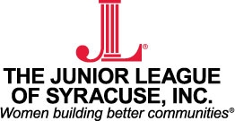 | New Member Application

Applicant Information
Name: |  |  |  | Date:
 | Last | First | M.I.

Address:
 | Street Address | Apartment/Unit #

 | City | State | ZIP Code

Phone: |  | Email

Cell Phone: |  | Birthdate:

How did you hear about the Junior League of Syracuse:

Name of member that referred you (if applicable): ___________________________________

Please rank (1-5) your reasons for wanting to join the Junior League of Syracuse:

__________ Volunteer Opportunities | __________Meet New People
__________ Training | __________ Networking
__________ Leadership | __________Other:_________________

Signature: |  | Date:

Please send to the JLS Office electronically or mail:

The Junior League of Syracuse
431 East Fayette St.
Syracuse, NY 13202
Phone: (315) 423-9773
Fax: (315) 471-1464
office@jlsyracuse.org

